Certificate of Analysis

General properties:
Name： OH-PEG2000-NHS
Molecular Weight： 2000 Dalton
Cat.#： R-1052
Lot.#： RO201604019
Manufacture Date： 2016.04.19
Date of Analysis： 2016.04.19
Recommended Retest date： 2017.04.19
Stability： 12 months
Storage： -20°C in the dark

Structure

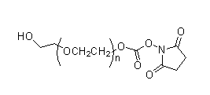

Items | Specification | Results
Appearance | White/off-white solid | White solid
¹H NMR | Identical to the Structure | Identical to the Structure
Foreign Material | None | None
Substitution | ＞90% | 90%
Report Date: 2016.04.19

This product is for research use only, Not for human or animal use

